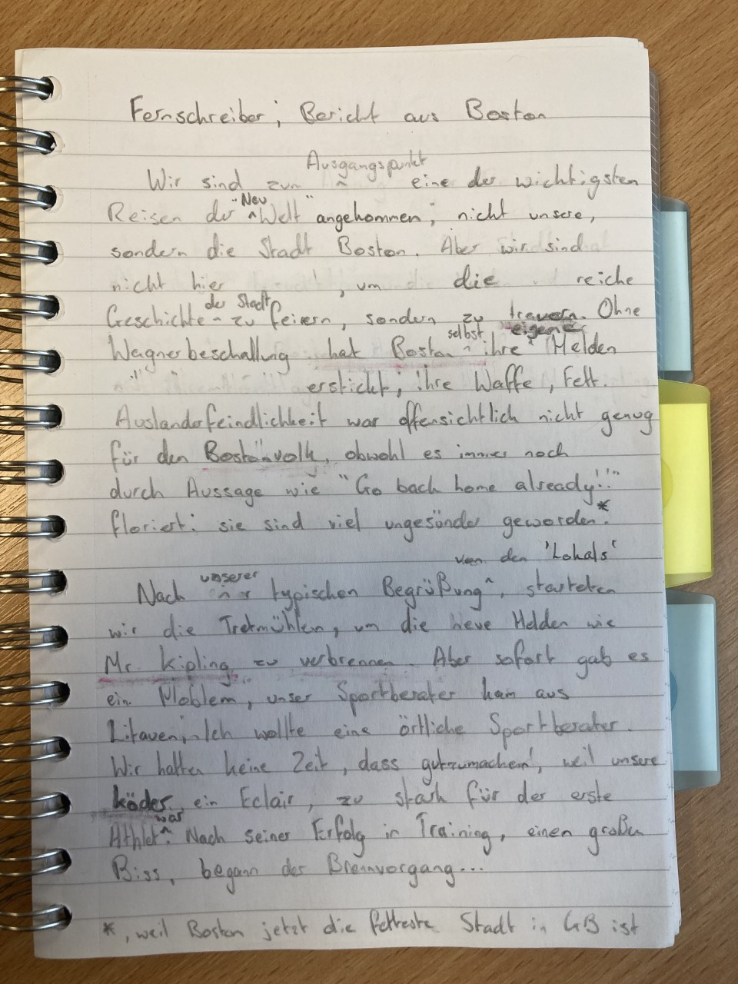

My notes, explaining word choices/decisions:
- Structurally, the text is presented as a past, recent past, present, future text; following a chronological order. You have Boston’s traditional history, 21st century history, current situation, followed by a slight indication toward the future.
- Simple notepad and paper, clear where mistakes/changes were made – added sense of authenticity: this is pre-published in the newspaper
- “Wir sind… der ‘Neuwelt’ angekommen” – Boston’s traditional past. The Pilgrim Fathers, who went on to sail the Mayflower in 1620 to Plymouth Rock, originally went to Boston (in short, their journey was Nottinghamshire to Boston, Boston to the Netherlands, return to England, travel to Plymouth, sail across to landing site at Plymouth Rock). Deliberately hid the specifics here; ‘Neuwelt’ makes it clear that it involved the journey to America, but unclear to what extent; intention was to replicate Schlingensief’s trope of presenting questions, while not really answering them.
- “Wir sind nicht…” – 1st person plural, same voice as in the Fernschreiber
- “…sondern zu trauern” – Rich historical significance ‘lost’/dead. Perhaps not very Schlingensiefisch, but I feel he would’ve been disappointed that Boston had a new legacy.
- “Ohne Wagnerbeschallung…” – Lots of Schlingensief’s work was inspired by moments in his life, so with this being set in around 2017, Deutschlandsuche ’99 would’ve happened almost 20 years prior to this: hence why I chose to have it as a referential point in my text.
- “…erstickt” – deliberate double meaning between English and German; ‘ersticken’ only presents connotations of murder in German, but in English, ‘smothered’ can also refer to something being covered with something, e.g. toast smothered in butter – murder (ersticken) by being covered in fat (smothered)
- “Bostonvolk” – starting to refer to recent past, with Boston being the town with the highest percentage of Brexit voters, plus a general lack of social integration between different ethnic groups in the town. Therefore, ‘Bostonvolk’ was chosen due to its significance in relation to the Nazis and their belief in racial superiority
- “obwohl… floriert:” – Unlike Boston’s legacy of being linked to journeys to the New World, which are dead (see “…sondern zu trauern”), Boston’s quasi-xenophobia still exists and is arguably getting stronger
- “viel ungesünder” – Now not only sick in terms of their attitudes, but physically unhealthy as well.
- “Nach unserer typischen Begrüßung…” – links to the “Go back home already” which appears earlier in the text: once again the referential writing-style of Schlingensief, not only events from years ago, but also events that happened only days or even hours before.

- “… von den ‘Lokals’ – I really liked the way you decided to create words in your own text, so this was my own attempt at making a word like ‘abständig’. ‘Lokals’, borrowing from ‘locals’ in English and ‘Lokal’, German word for pub: in my head, the word means ‘the pub regulars’. On the map below, I’ve marked two points, a pub and where the TV crew set up. In my mind, I imagined Schlingensief driving past the pub in his Volvo and hearing the ‘Lokals’ in the beer garden shouting at him as they hear someone speaking a foreign language through a loudspeaker.
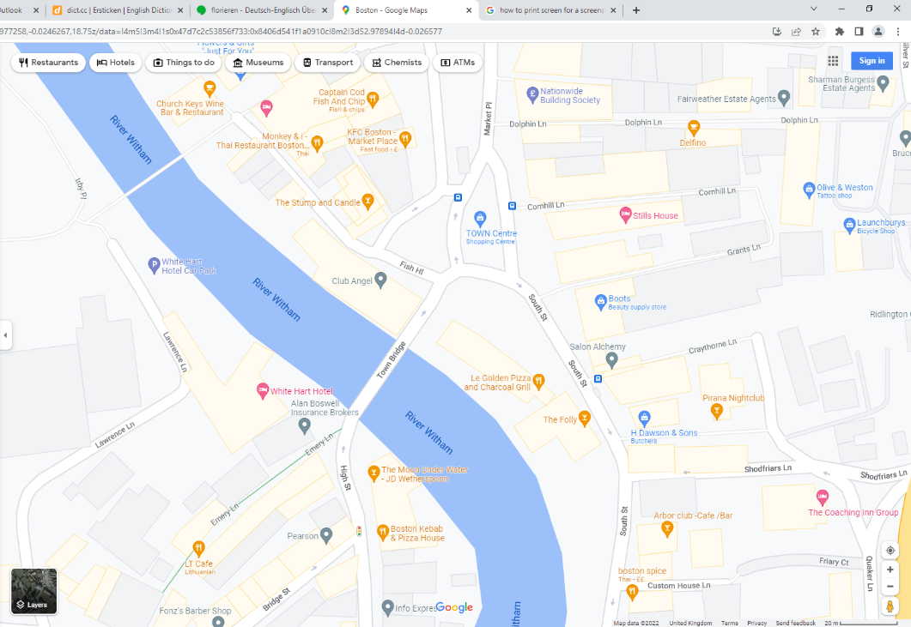
This is where the treadmills were set up in the TV show
‘The Moon Under Water’ Pub – attracts a bad crowd in Boston, and you drive past it to get to where the treadmills were set up.

- “starteten wir die Tretmühlen…” – simple, trivial action being described. Important to consider this alongside my next note
- “…um… zu verbrennen” – grand aim of Schlingensief. Having this next to a simple description of events was common in the Fernschreiber. Also, going back to my structural point, we are now in the ‘present’ section, where we’re describing the project
- “…um die neue Helden wie Mr. Kipling zu verbrennen” – Again this was in part inspired by your text and your decision to use the same words as Schlingensief, for example ‘beschallen’. In his Bericht aus Weimar, Schlingensief uses the line “Denn das Zentrum verbrennt die Helden”, so I’ve used the same verb form in my text. Additionally, ‘Mr. Kipling’ is a named hero, just like ‘Goethe’ und ‘Schiller’ in Bericht aus Weimar, but it has a greater significance; you have ‘Mr. Kipling’, the popular cake brand, as a personification of Boston’s new problem, it’s obesity, so he is a hero of the people; but as well as this, ‘Mr. Kipling’ adds greater meaning to the verb form ‘verbrennen’, as you have not only ‘burn’ in terms of dying, but also ‘burn’ as in to burn fat.

- “unser Sportberater… örtliche Sportberater.” – Perhaps not a feature of the Fernschreiber, but is designed to reflect Boston’s problem with social integration, but this time in Schlingensief’s own words (sort of). There are a lot of Lithuanians in Boston, so it would be more than likely that there would be personal trainers from Lithuania. Therefore, the trainer would be local to Boston. Aim here was to do a version of Bitte liebt Österreich, where Schlingensief spoke directly to the people in Austria to make sure they are confronted with what is happening in his mind: perhaps if I were to do this project again, I would make it clear from the beginning that this was to be published in the local paper in Boston, rather than FAZ, to give this point a greater significance.
- “… weil unsere Köder… einen großen Biss” – In my mind, if this project were done by Schlingensief, it would have been more blunt. Word choices here reflect this. Again, if you take Bitte Liebt Österreich, he never minced his words, so I feel that the same would’ve happened in this project, however as a personal choice, I wanted to add a harsher tone here as a way of expressing my interpretation of Schlingensief’s work; his art often reflects a harsh reality. For example, describing the éclair as bait, or how training for the treadmill run was simply taking a big bite.
- “…begann der Brennvorgang…” – deliberately choosing to leave this as an open-ended text as a hint towards the future; rather than using a word specifically meaning exercise, I chose to use ‘Brennvorgang’, the ‘burning process’, again to relate this project to the idea of not just burning fat, but also burning heroes. In addition, I chose ‘Brennvorgang’ because of its mechanical connotations, with the idea being to try and present this project in Boston as a ‘Bildstörungsmaschine’, where an image of Boston is presented, but it will inevitably interrupt itself in the future given how Boston’s legacy has changed so greatly in recent years

